Clip File – OPIS by IHS Markit
Dan Macy
Markets Editor – Renewable Fuels
2018-2019

JAN. 2019 **White House, Congress Agree to Reopen Government for Three Weeks
Published on OPISAlerts for Alternative Fuels
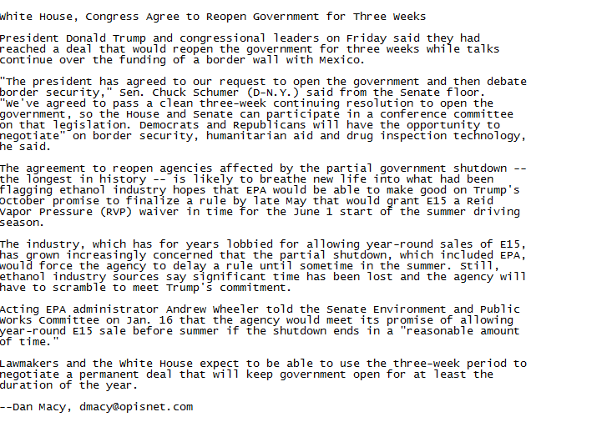

JAN. 2019 — **Study Supplements Look at E85 Demand Growth with Fuel Price Data
Published on OPISAlerts for Alternative Fuels

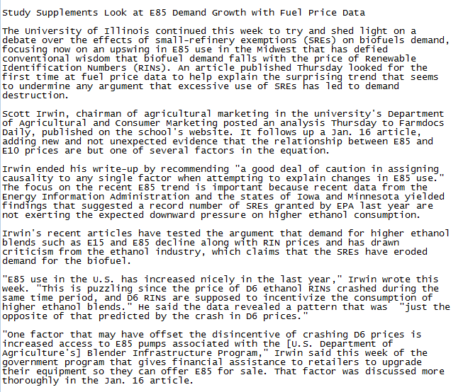
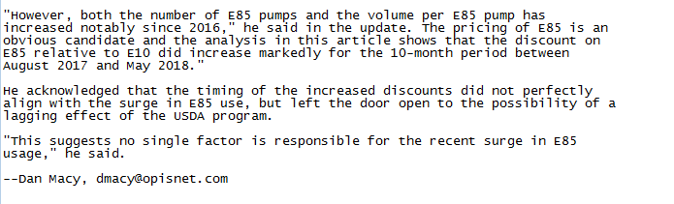

JAN. 2019 – **Firm: Robust ’19 for Biodiesel; Pressure for Ethanol, Advanced Biofuel
Published in OPISAlerts-Alternative Fuels
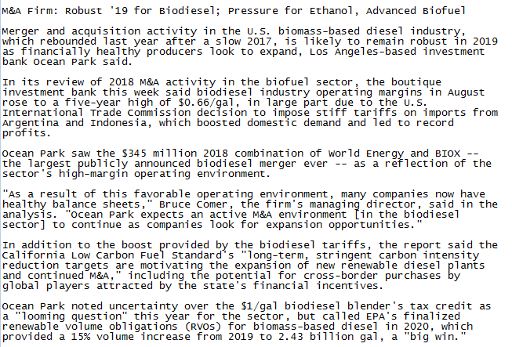
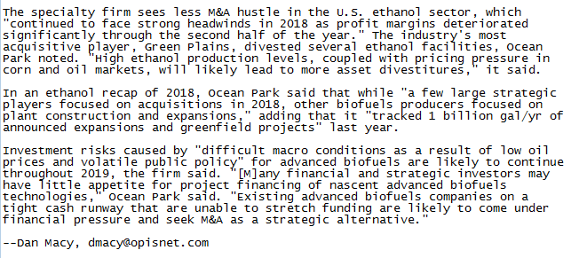

JAN. 2019 **ExxonMobil, REG Join Forces with Clariant on Cellulosic Biodiesel R&D Project
Published OPISAlerts – Renewable Fuels

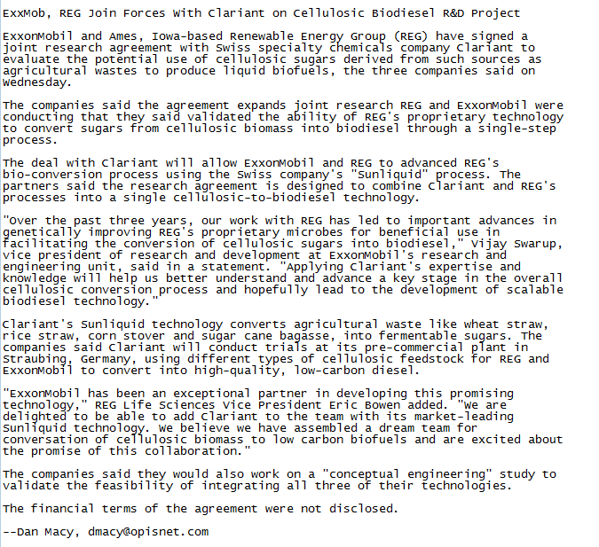

2018—DECEMBER **Aemetis Secures Capital to Build Calif. Biogas Operations

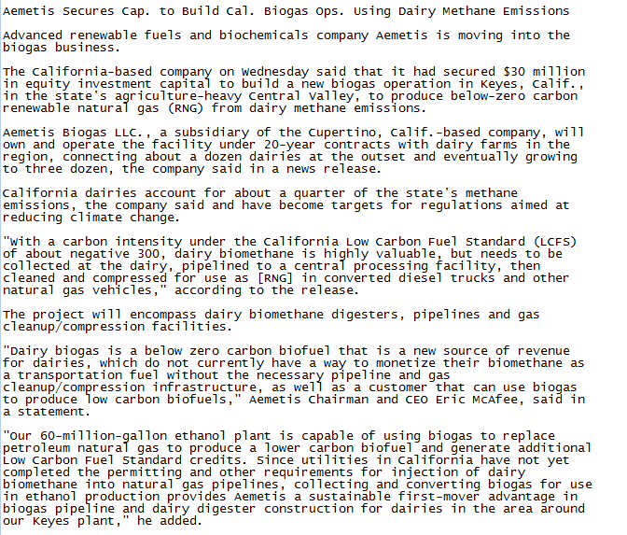
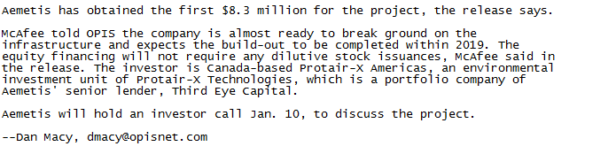

2018—DECEMBER 4 ** California Low Carbon Fuel Standard Driving ‘Seismic Shift’ West
In Renewable Diesel Market

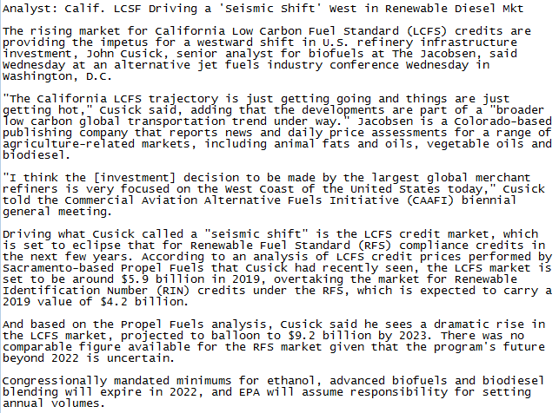

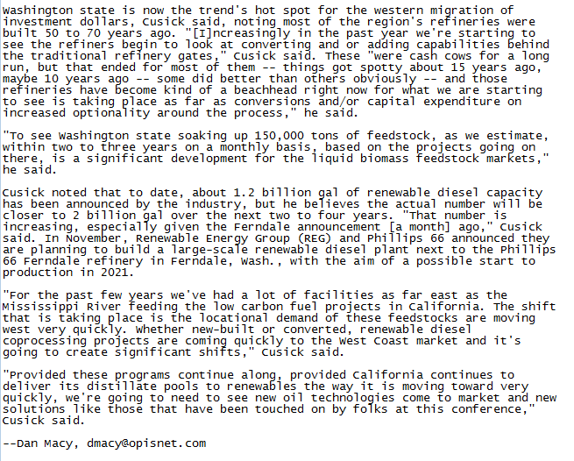

2018— **Panel to Decide Merits in Advanced Biofuels Association Lawsuit Against EPA over Small Refinery Exemptions
Published: OPISAlerts—Alternative Fuels
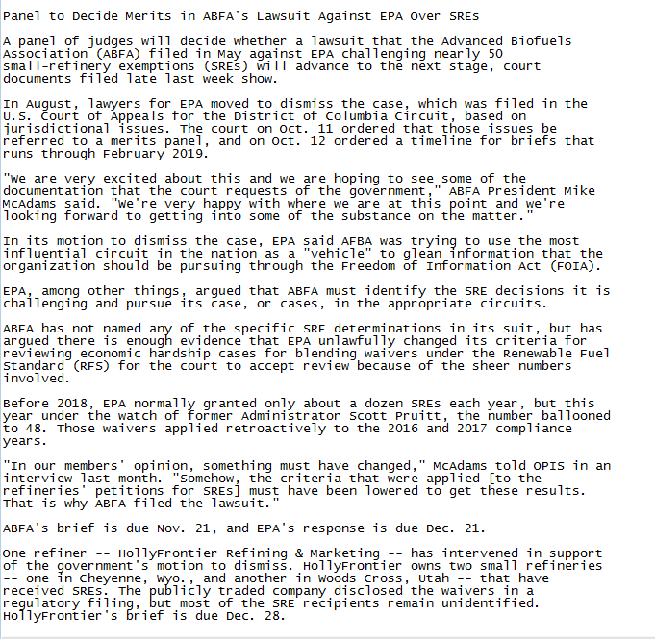

2018—APRIL **China Makes Good on Threat to Increase Tariffs on U.S. Ethanol Exports
Published in: OPISAlerts – Renewable Fuels
Chemical Week

